**VISVESVARAYA TECHNOLOGICAL UNIVERSITY**

**“JnanaSangama”, Belgaum -590014, Karnataka.**



**LAB REPORT**

**on**

**OBJECT ORIENTED JAVA PROGRAMMING**

***Submitted by***

**Yapara karthikeya (1BM21CS249)**

***in partial fulfillment for the award of the degree of***

**BACHELOR OF ENGINEERING**

***in***

**COMPUTER SCIENCE AND ENGINEERING**



**B.M.S. COLLEGE OF ENGINEERING**

**(Autonomous Institution under VTU)**

**BENGALURU-560019**

**Oct 2022-Feb 2023**

**B. M. S. College of Engineering,**

**Bull Temple Road, Bangalore 560019**

(Affiliated To Visvesvaraya Technological University, Belgaum)

**Department of Computer Science and Engineering**



**CERTIFICATE**

This is to certify that the Lab work entitled “**OBJECT ORIENTED JAVA PROGRAMMING**” carried out by **Yapara karthikeya(1BM21CS249),** who is bonafide student of **B. M. S. College of Engineering.** It is in partial fulfillment for the award of **Bachelor of Engineering in Computer Science and Engineering** of the Visvesvaraya Technological University, Belgaum during the year 2022-23. The Lab report has been approved as it satisfies the academic requirements in respect of Java Lab **- (22CS3PCOOJ)** work prescribed for the said degree.

Name of the Lab-Incharge               **Dr. Jyothi S Nayak**

Designation Professor and Head

Department of CSE Department of CSE

BMSCE, Bengaluru BMSCE, Bengaluru

`

**Index Sheet**

|  |  |  |
| --- | --- | --- |
| **Sl. No.** | **Experiment Title** | **Page No.** |
| 1 | Develop a Java program that prints all real solutions to the quadratic equation ax2+bx+c = 0. Read in a, b, c and use the quadratic formula. If the discriminate b2 -4ac is negative, display a message stating that there are no real solutions. | 5 |
| 2 | Develop a Java program to create a class Student with members usn, name, an array credits and an array marks. Include methods to accept and display details and a method to calculate SGPA of a student. | 8 |
| 3 | Create a class Book which contains four members: name, author, price, num_pages. Include a constructor to set the values for the members. Include methods to set and get the details of the objects. Include a toString( ) method that could display the complete details of the book. Develop a Java program to create n book objects. | 12 |
| 4 | Develop a Java program to create an abstract class named Shape that contains two integers and an empty method named printArea( ). Provide three classes named Rectangle, Triangle and Circle such that each one of the classes extends the class Shape. Each one of the classes contain only the method printArea( ) that prints the area of the given shape | 17 |
| 5 | Bank program. | 20 |
| 7 | Write a program that demonstrates handling of exceptions in inheritance tree. Create a base class called “Father” and derived class called “Son” which extends the base class. In Father class, implement a constructor which takes the age and throws the exception WrongAge( ) when the input age=father’s age. | 33 |
| 8 | Write a program which creates two threads, one thread displaying “BMS College of Engineering” once every ten seconds and another displaying “CSE” once every two seconds | 37 |
| 9 | Create a package CIE which has two classes- Student and Internals. The class Personal has members like usn, name, sem. The class internals has an array that stores the internal marks scored in five courses of the current semester of the student. Create another package SEE which has the class External which is a derived class of Student. This class has an array that stores the SEE marks scored in five courses of the current semester of the student. Import the two packages in a file that declares the final marks of n students in all five courses. | 40 |

**Course Outcome**

|  |  |
| --- | --- |
| CO1 | Apply the knowledge of java concepts to find the solution for a given solution |
| CO2 | Analyze the given java application for correctness |
| CO3 | Develop Java programs for a given requirement |
| CO4 | Conduct practical experiments for demonstrating features of java |

**LAB PROGRAM 1:**

Q: Develop a Java program that prints all real solutions to the quadratic equation ax2+bx+c = 0. Read in a, b, c and use the quadratic formula. If the discriminate b2 -4ac is negative, display a message stating that there are no real solutions.

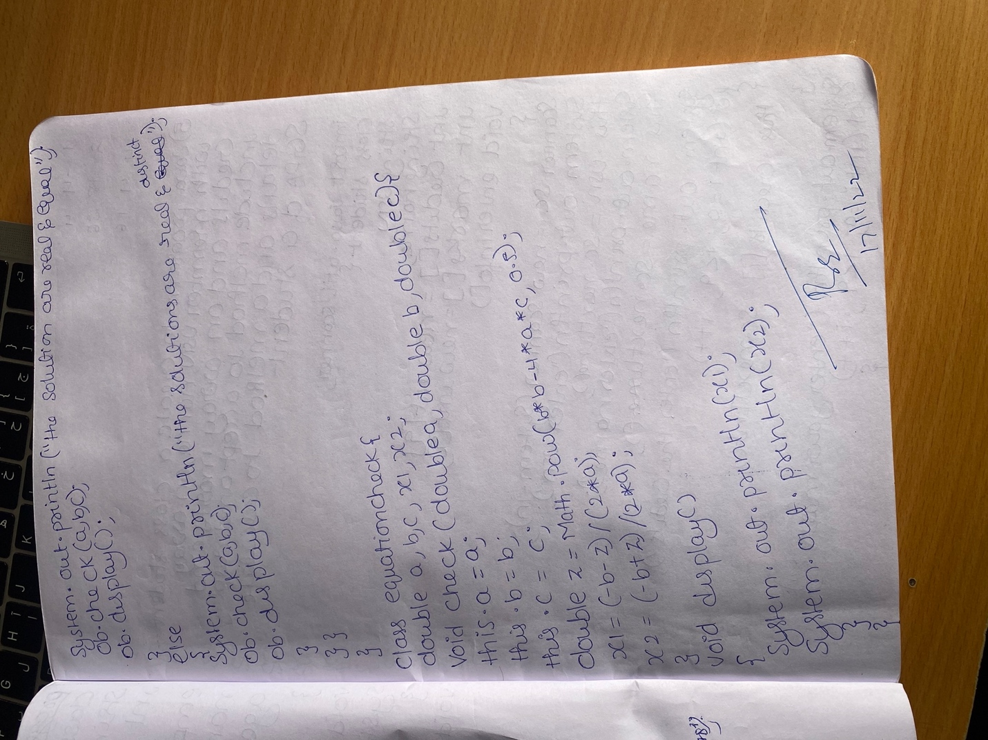

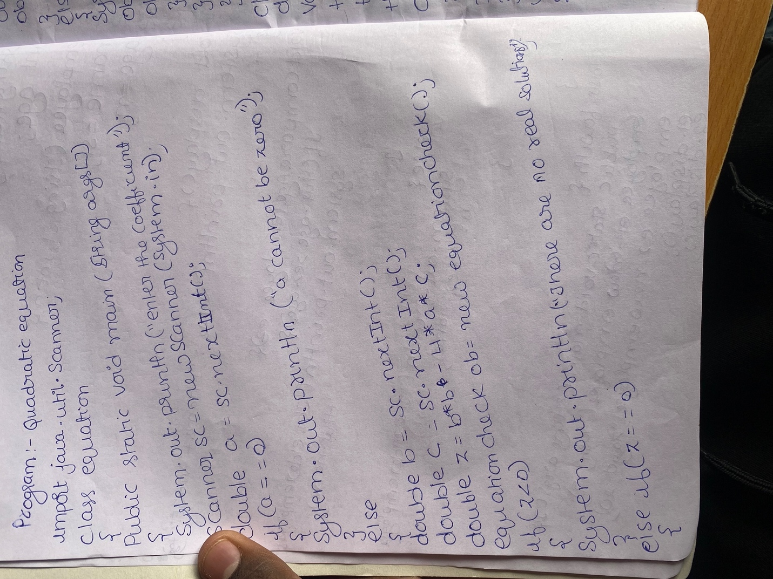

**Output:**

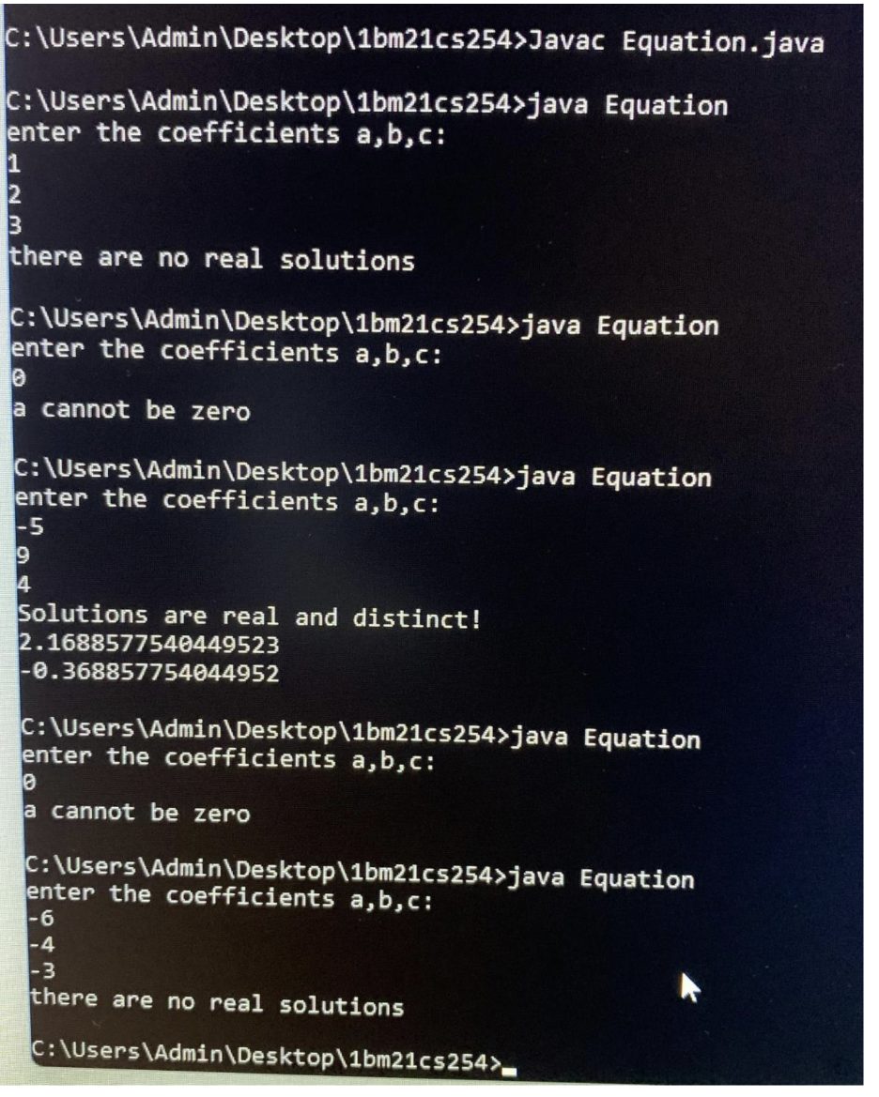

**LAB PROGRAM 2:**

**Q:** Develop a Java program to create a class Student with members usn, name, an array credits and an array marks. Include methods to accept and display details and a method to calculate SGPA of a student.

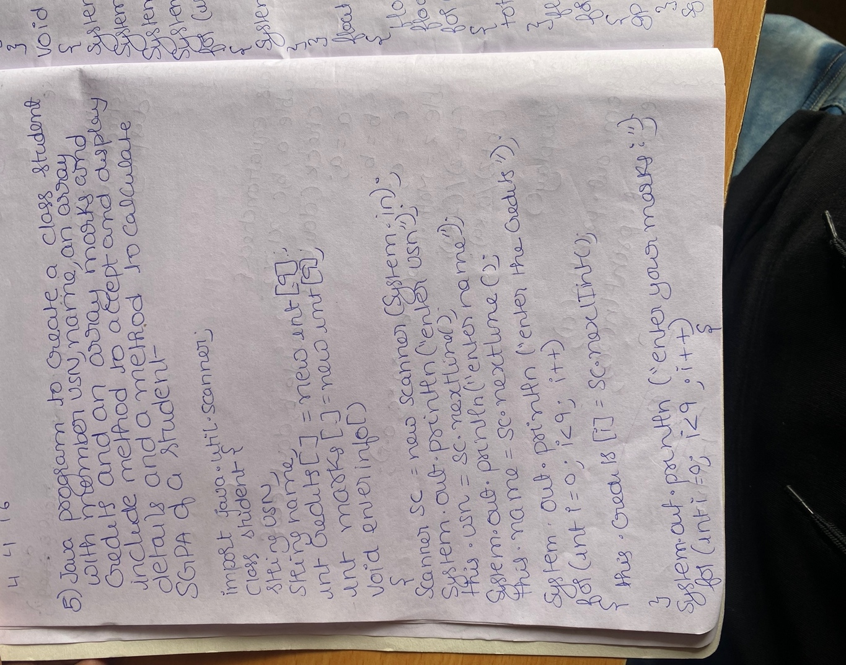

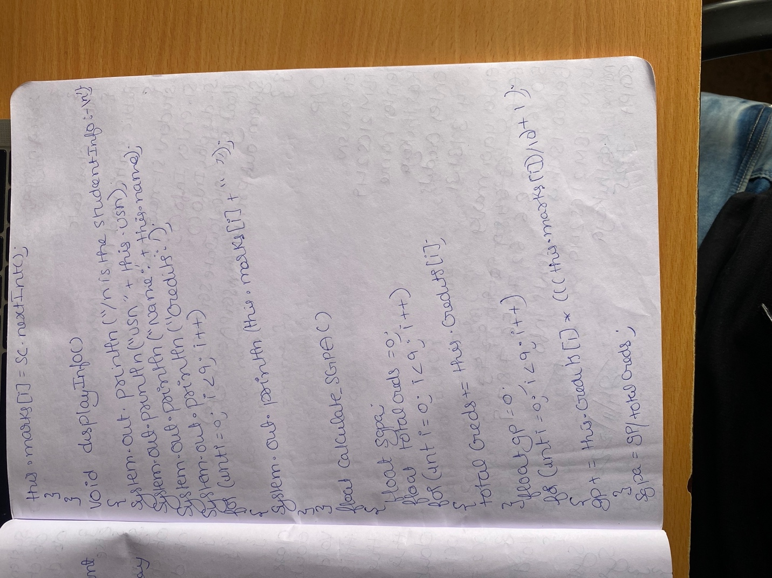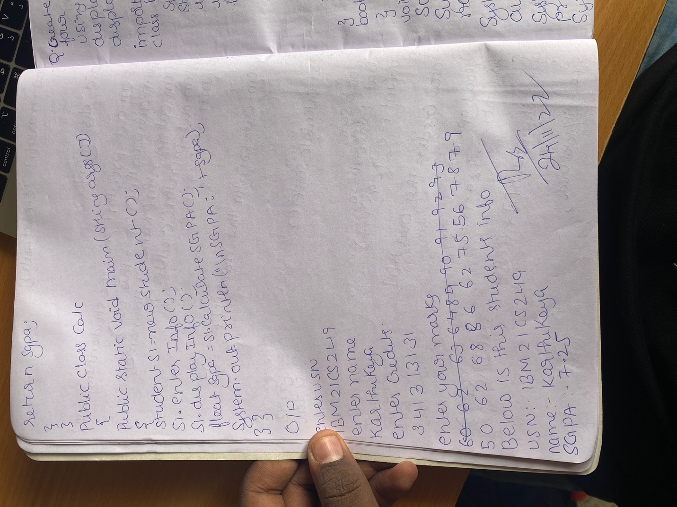

**Output:**

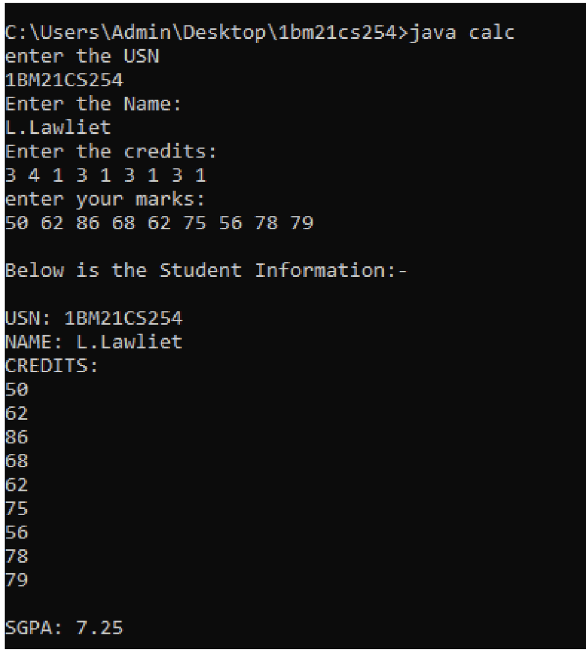

**LAB PROGRAM 3:**

**Q:** Create a class Book which contains four members: name, author, price, num_pages. Include a constructor to set the values for the members. Include methods to set and get the details of the objects. Include a toString( ) method that could display the complete details of the book. Develop a Java program to create n book object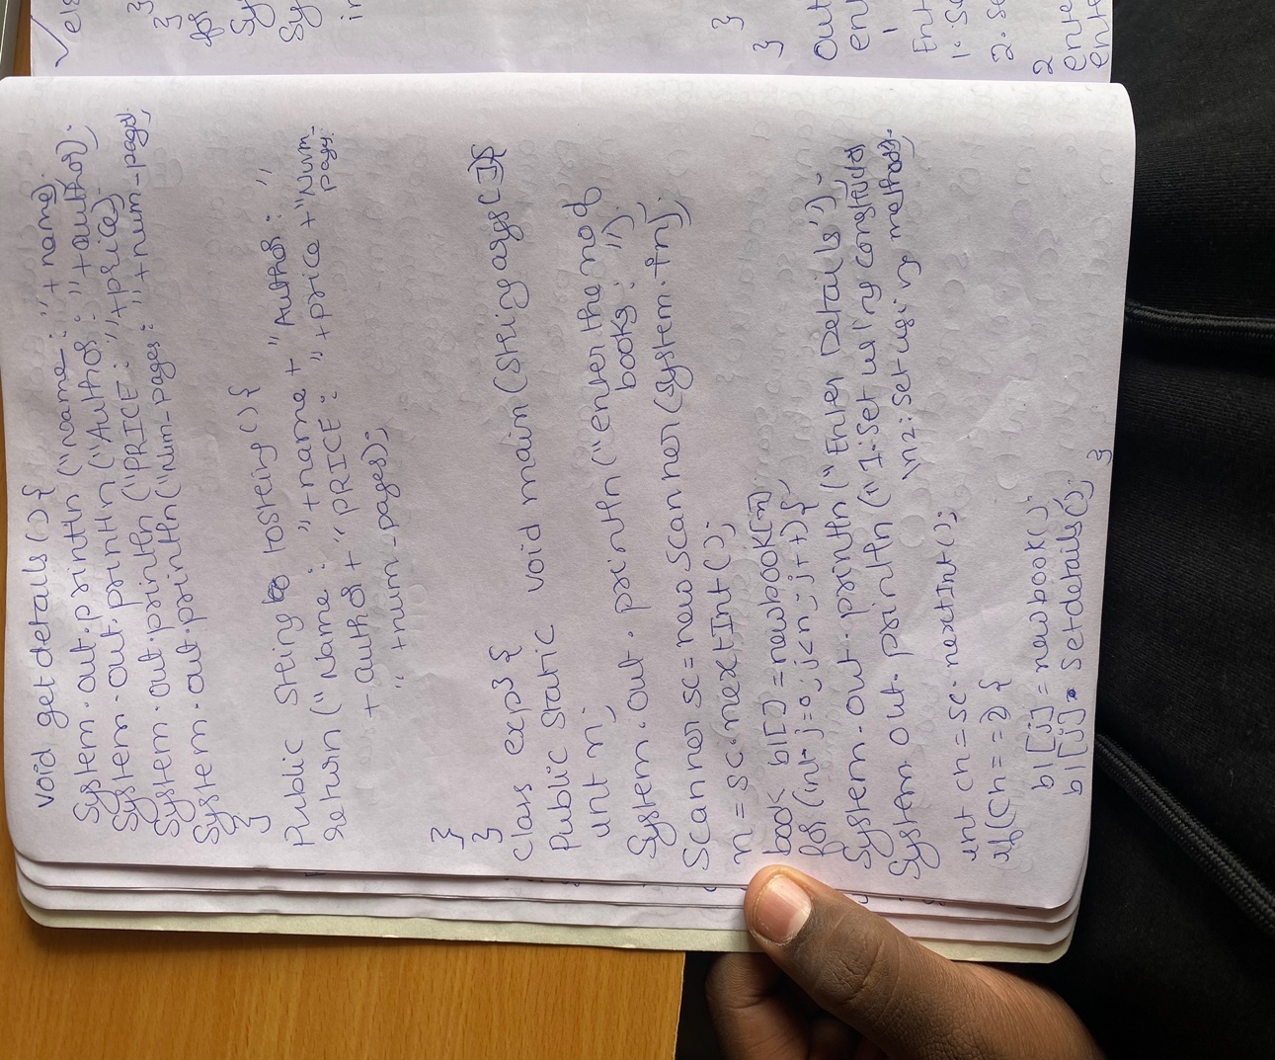s.

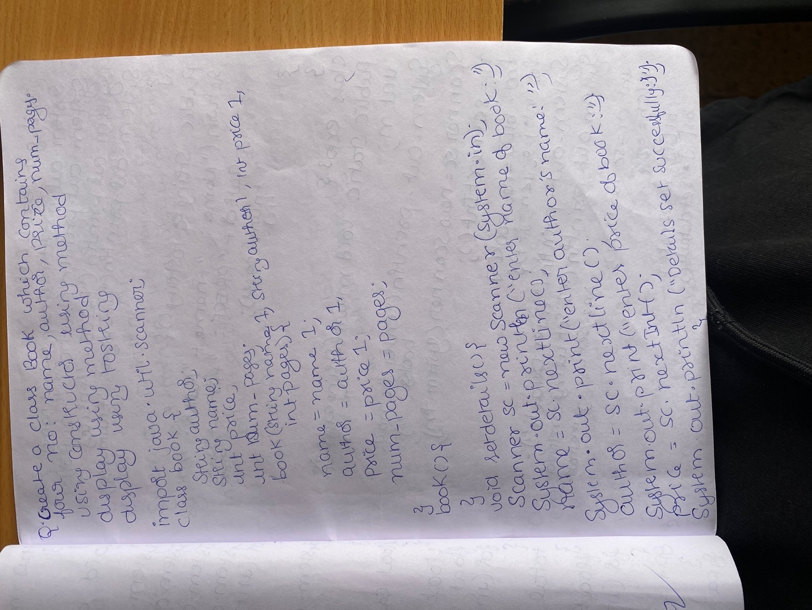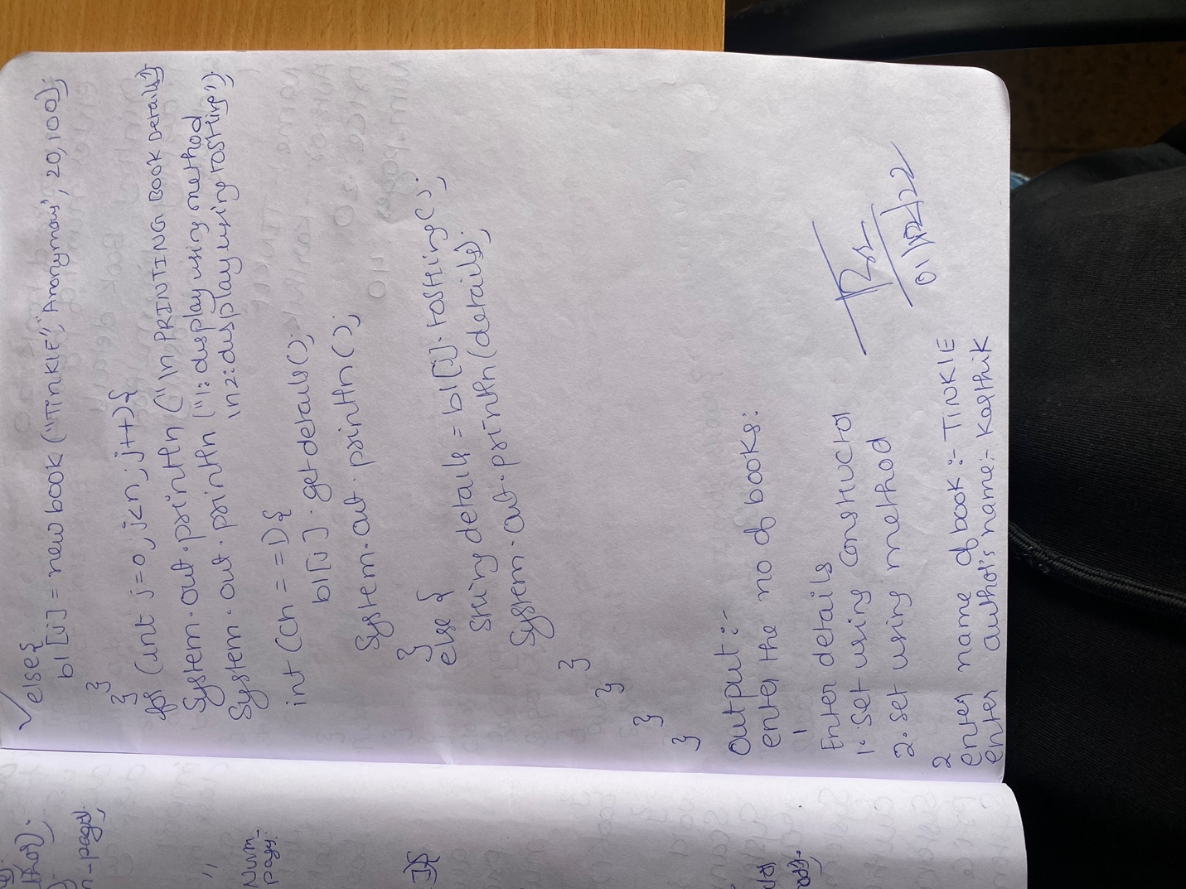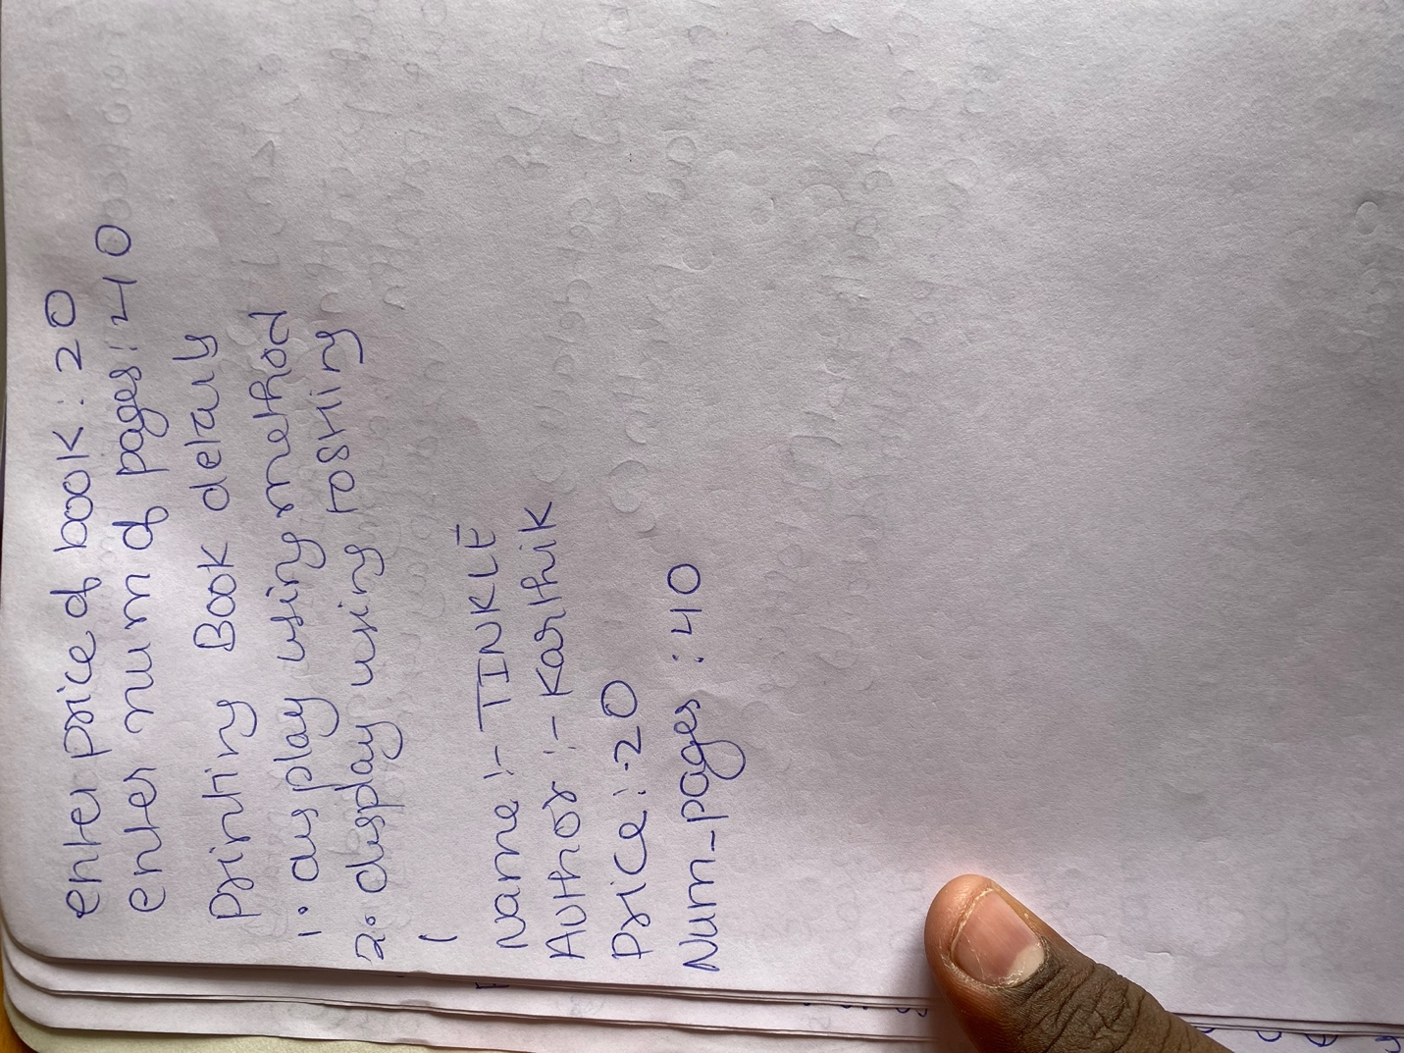

**Output:**

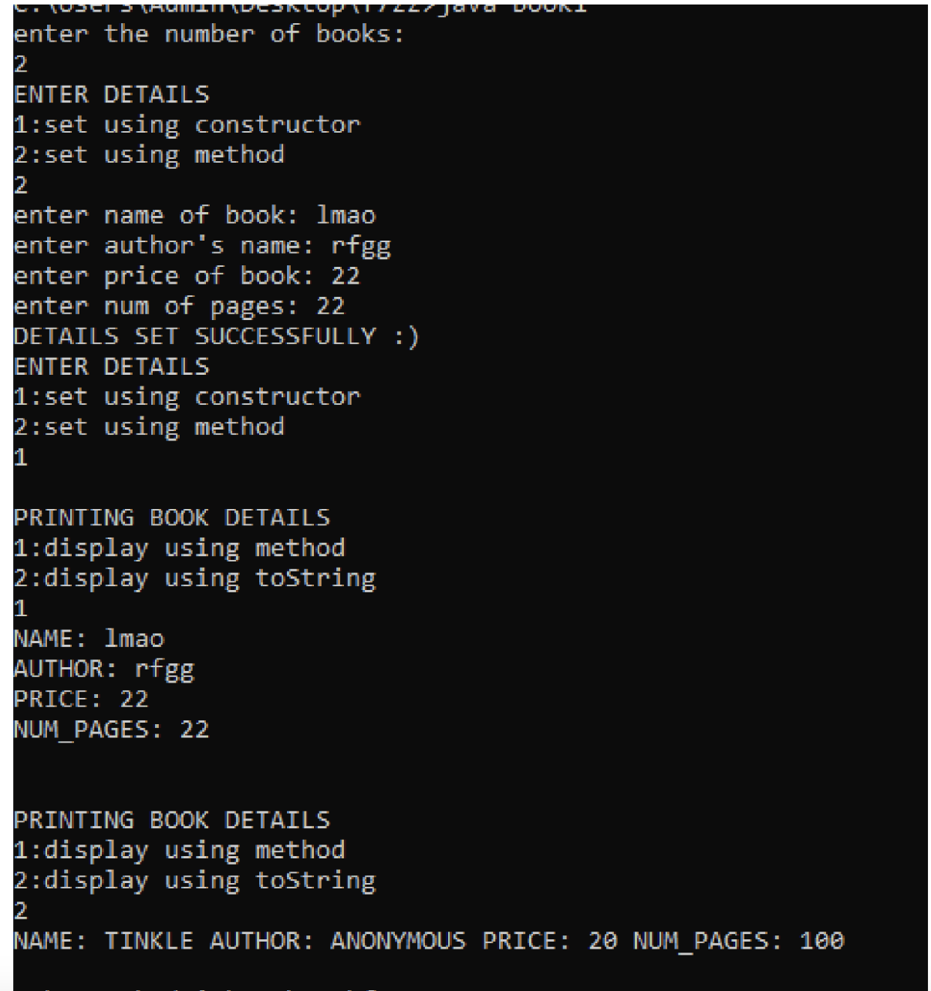

**LAB PROGRAM 4:**

**Q:** Develop a Java program to create an abstract class named Shape that contains two integers and an empty method named printArea( ). Provide three classes named Rectangle, Triangle and Circle such that each one of the classes extends the class Shape. Each one of the classes contain only the method printArea( ) that prints the area of the given shape. 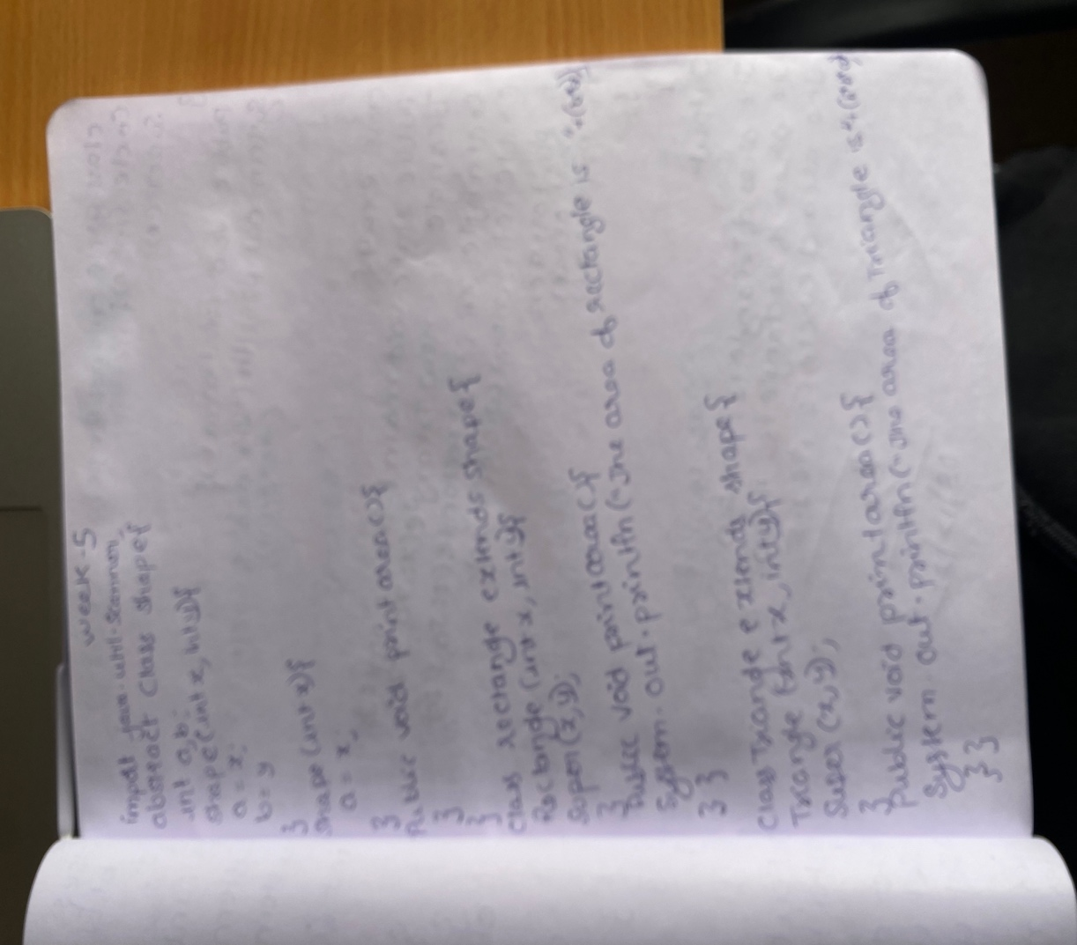

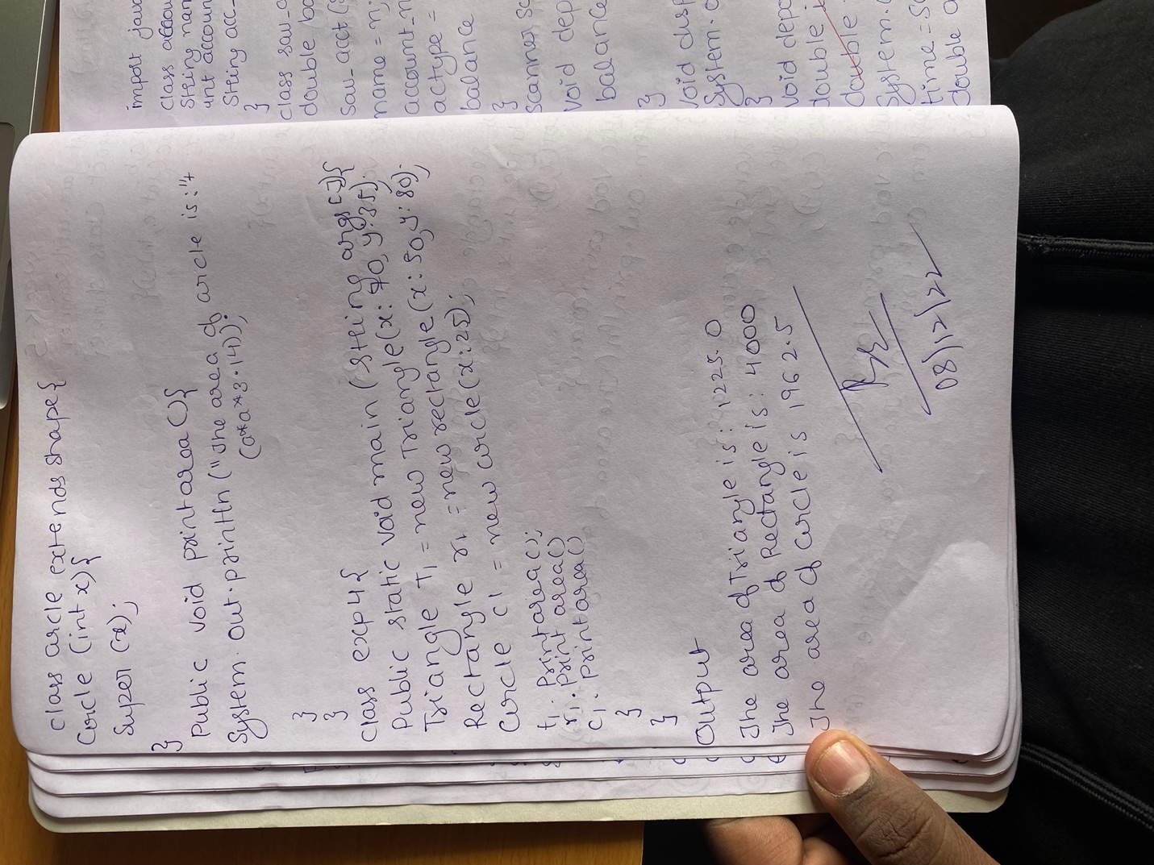

**Output:**

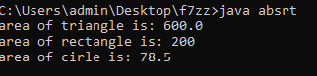

**LAB PROGRAM 5:**

**Q:** Develop a Java program to create a class Bank that maintains two kinds of account for its customers, one called savings account and the other current account. The savings account provides compound interest and withdrawal facilities but no cheque book facility. The current account provides cheque book facility but no interest. Current account holders should also maintain a minimum balance and if the balance falls below this level, a service charge is imposed.

Create a class Account that stores customer name, account number and type of account. From this derive the classes Cur-acct and Sav-acct to make them more specific to their requirements.

Include the necessary methods in order to achieve the following tasks:

a) Accept deposit from customer and update the balance.

b) Display the balance.

c) Compute and deposit interest

d) Permit withdrawal and update the balance Check for the minimum balance, impose penalty if necessary and update the balance.

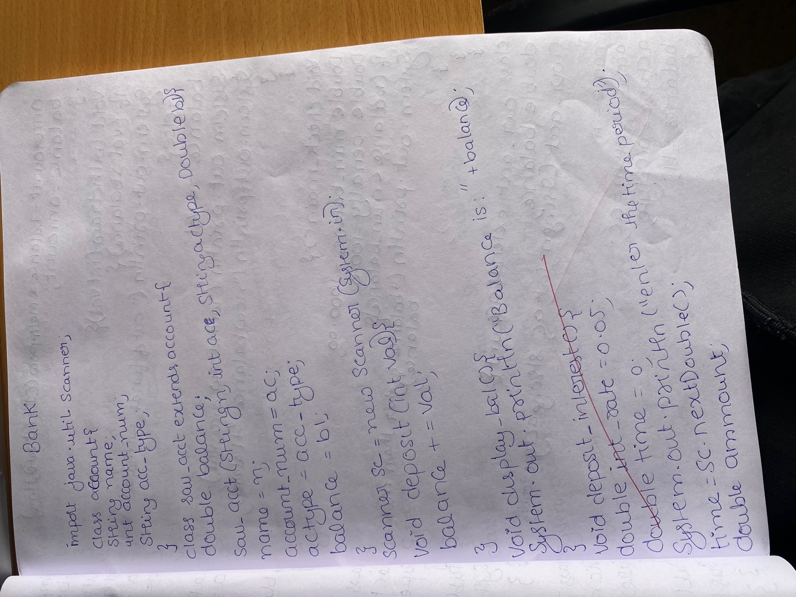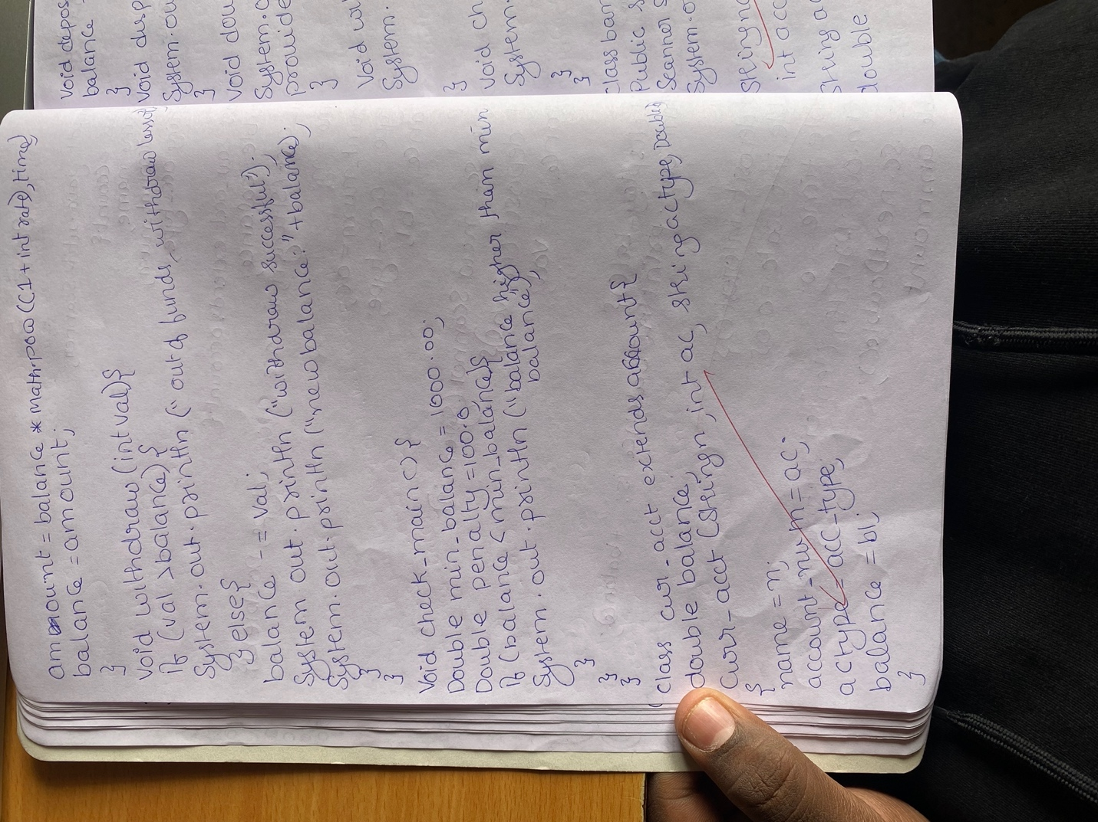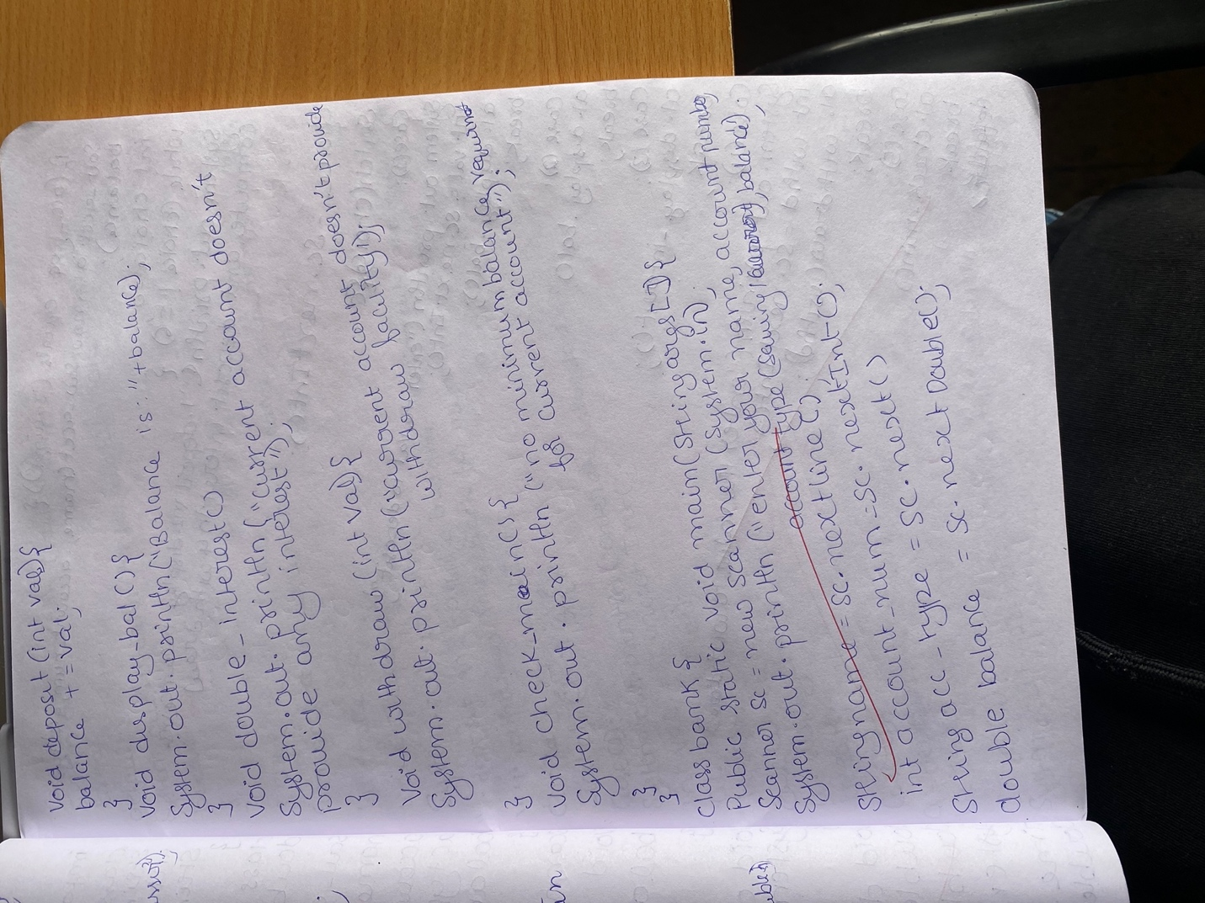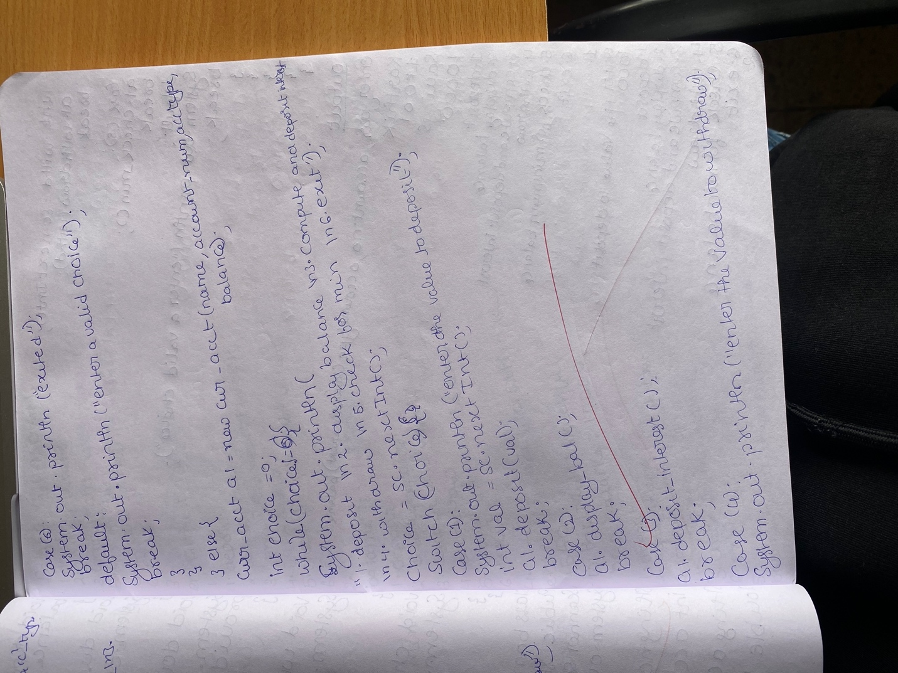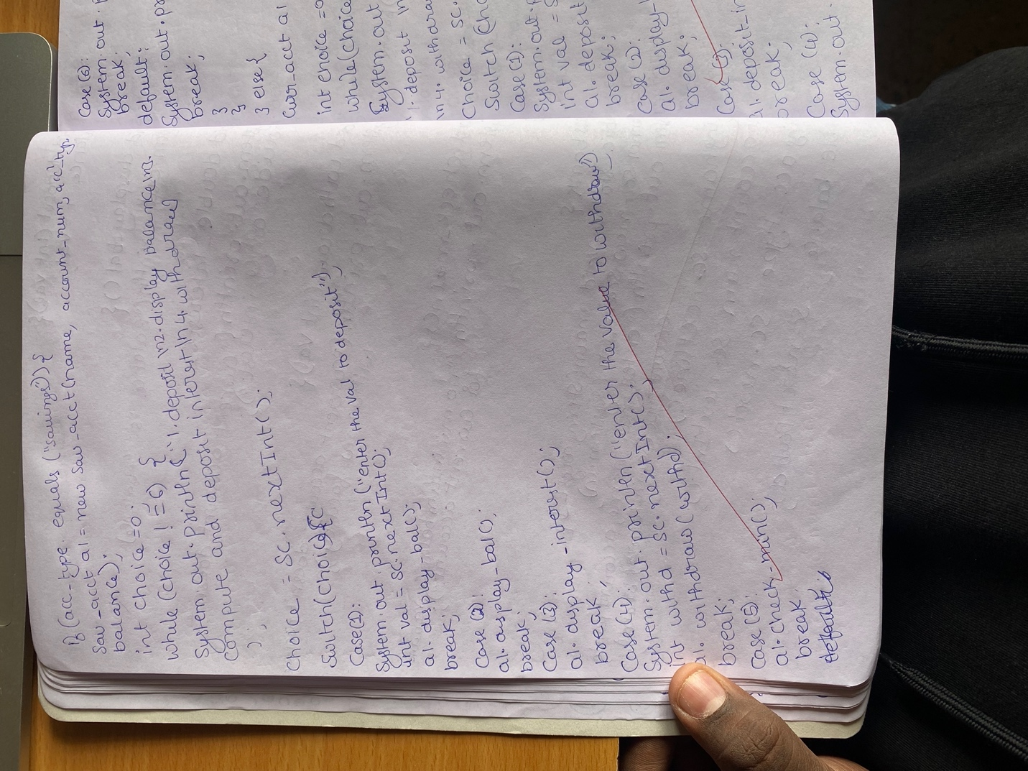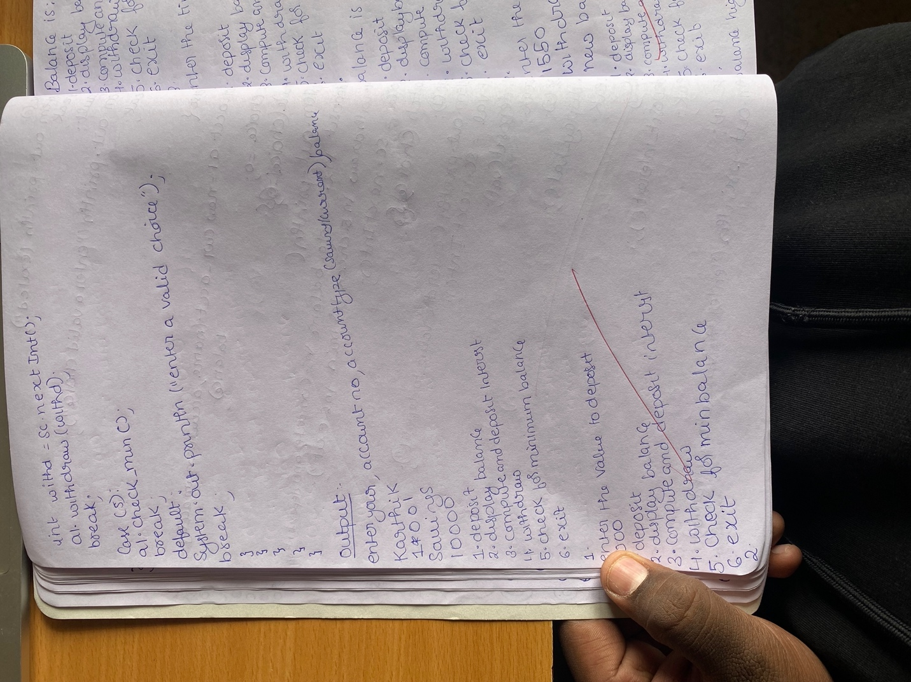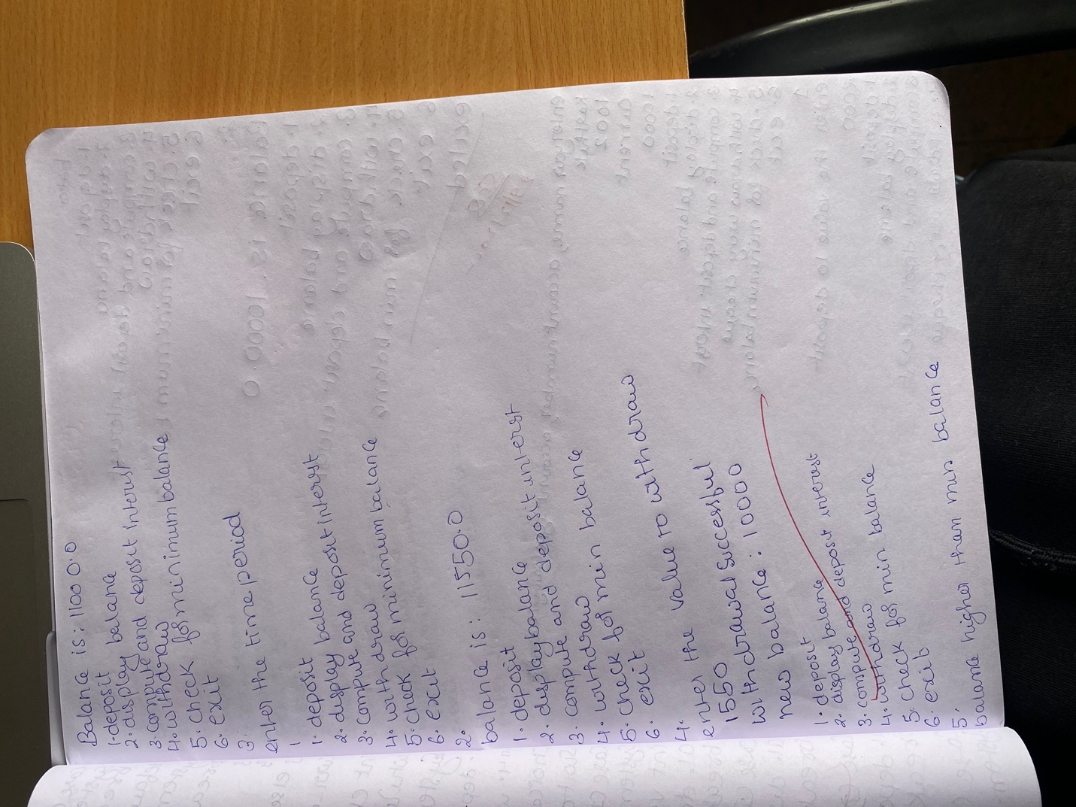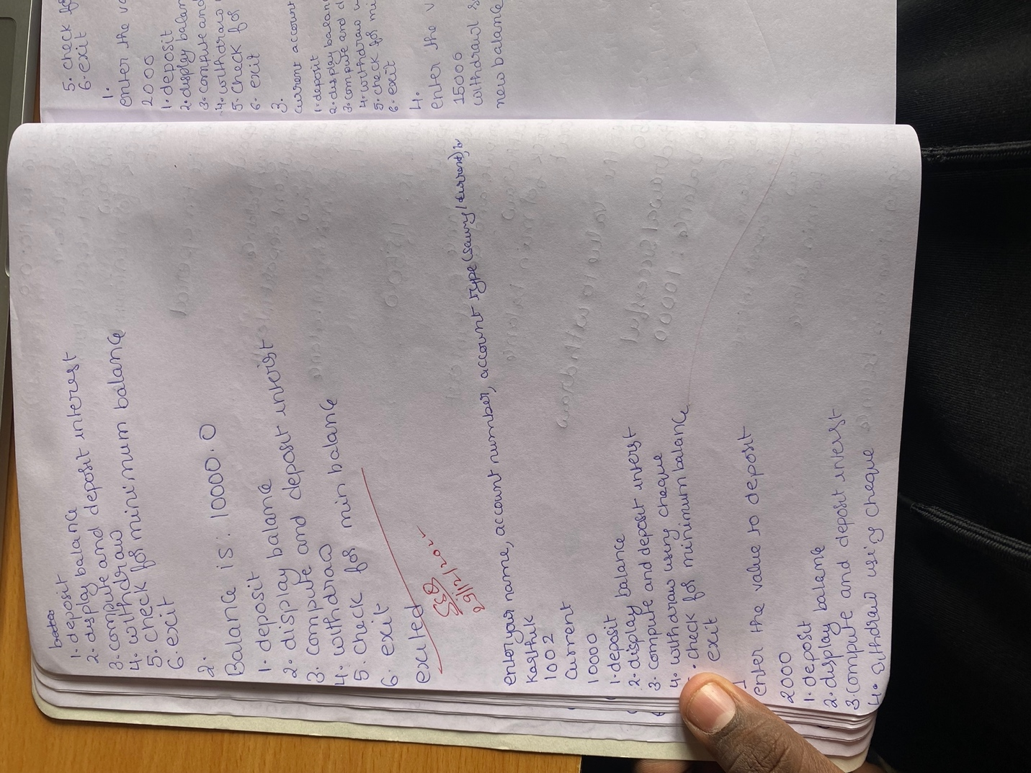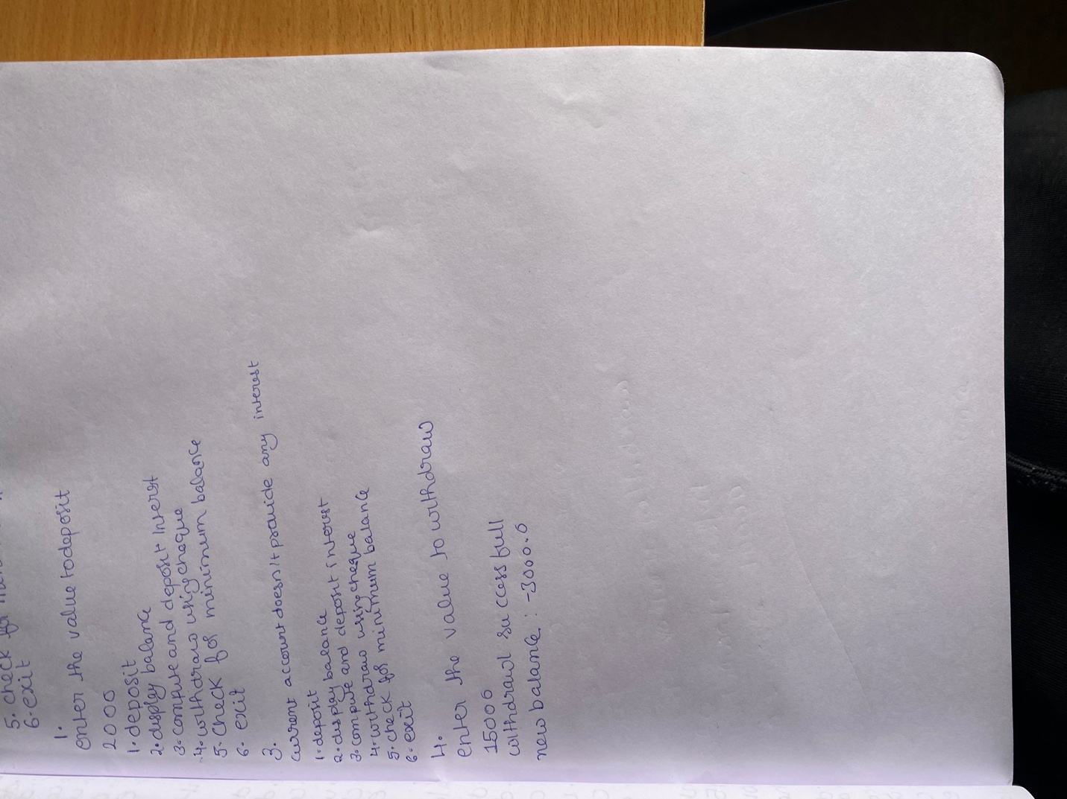

**Output for savings:**

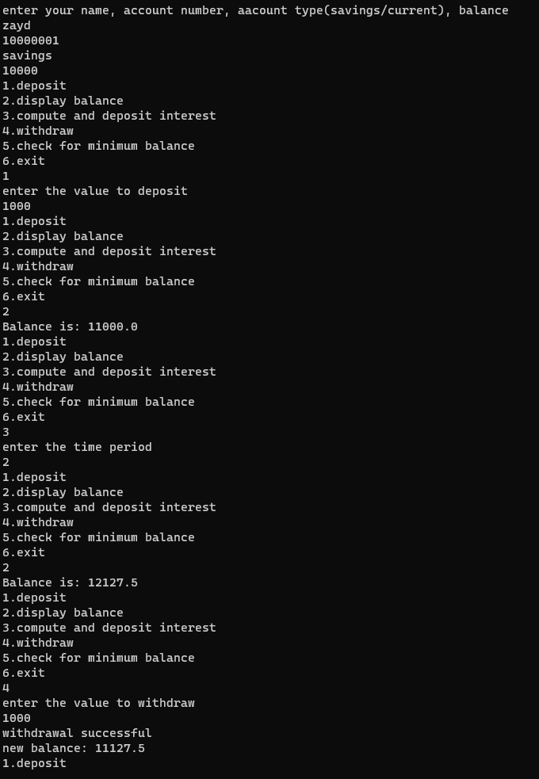

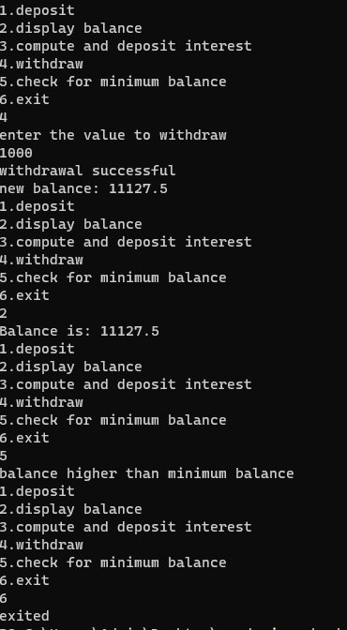

**Output for current:**

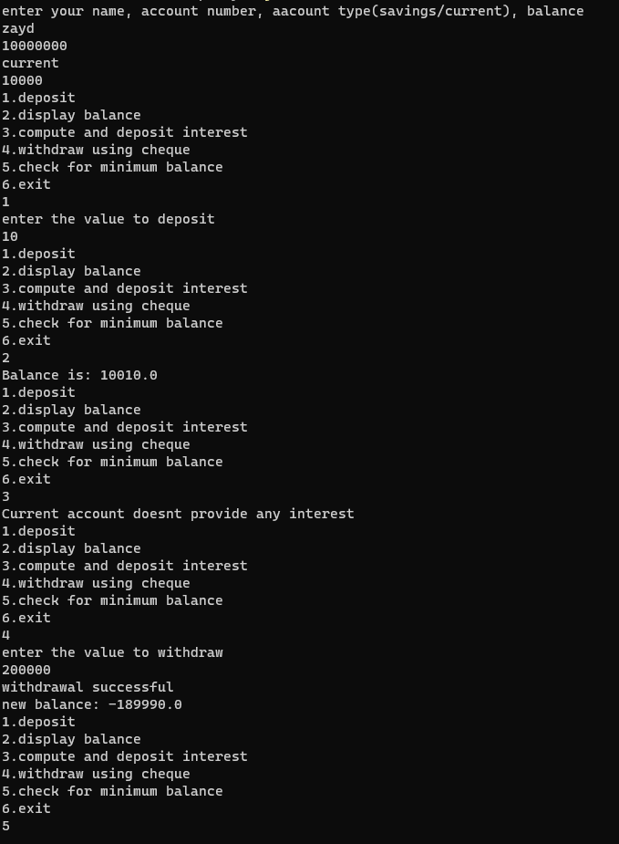

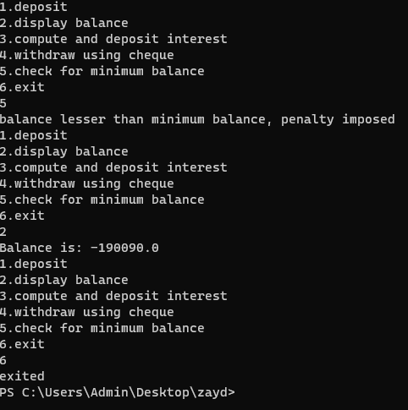

**LAB PROGRAM 7:**

**Q:** Write a program that demonstrates handling of exceptions in inheritance tree. Create a base class called “Father” and derived class called “Son” which extends the base class. In Father class, implement a constructor which takes the age and throws the exception WrongAge( ) when the input age=father’s age.

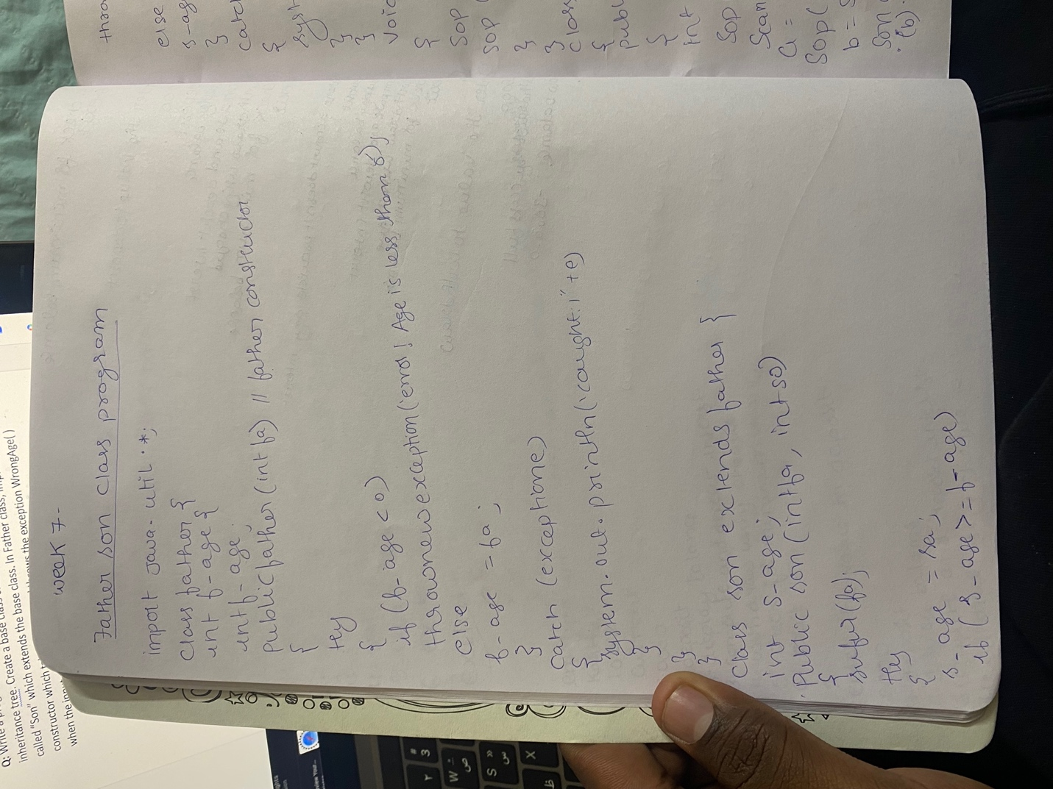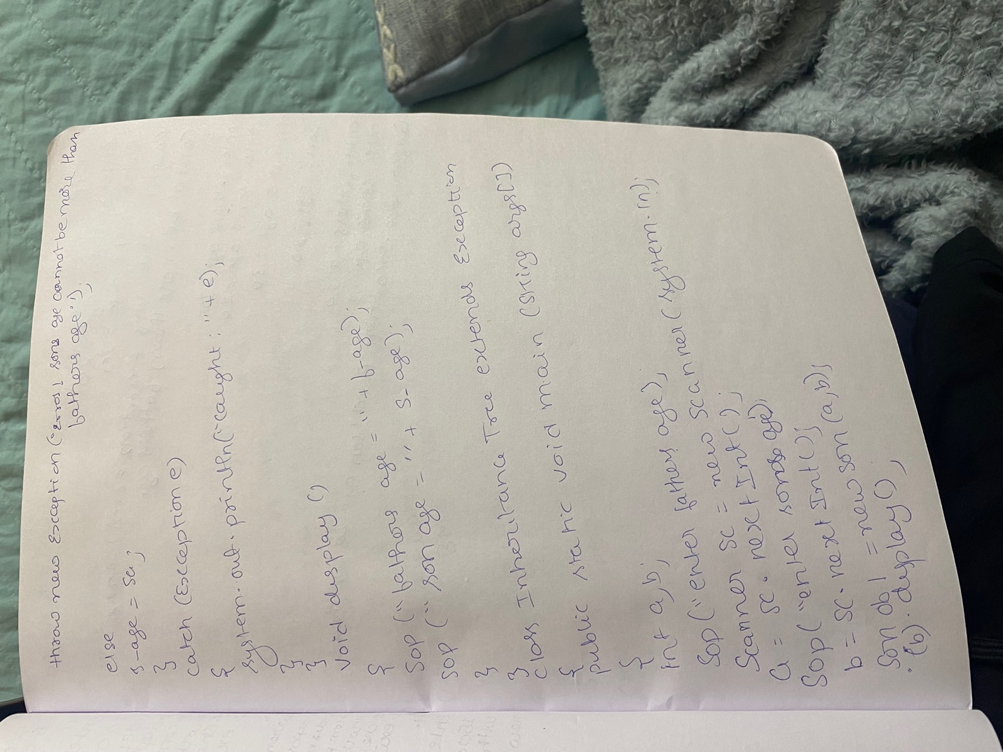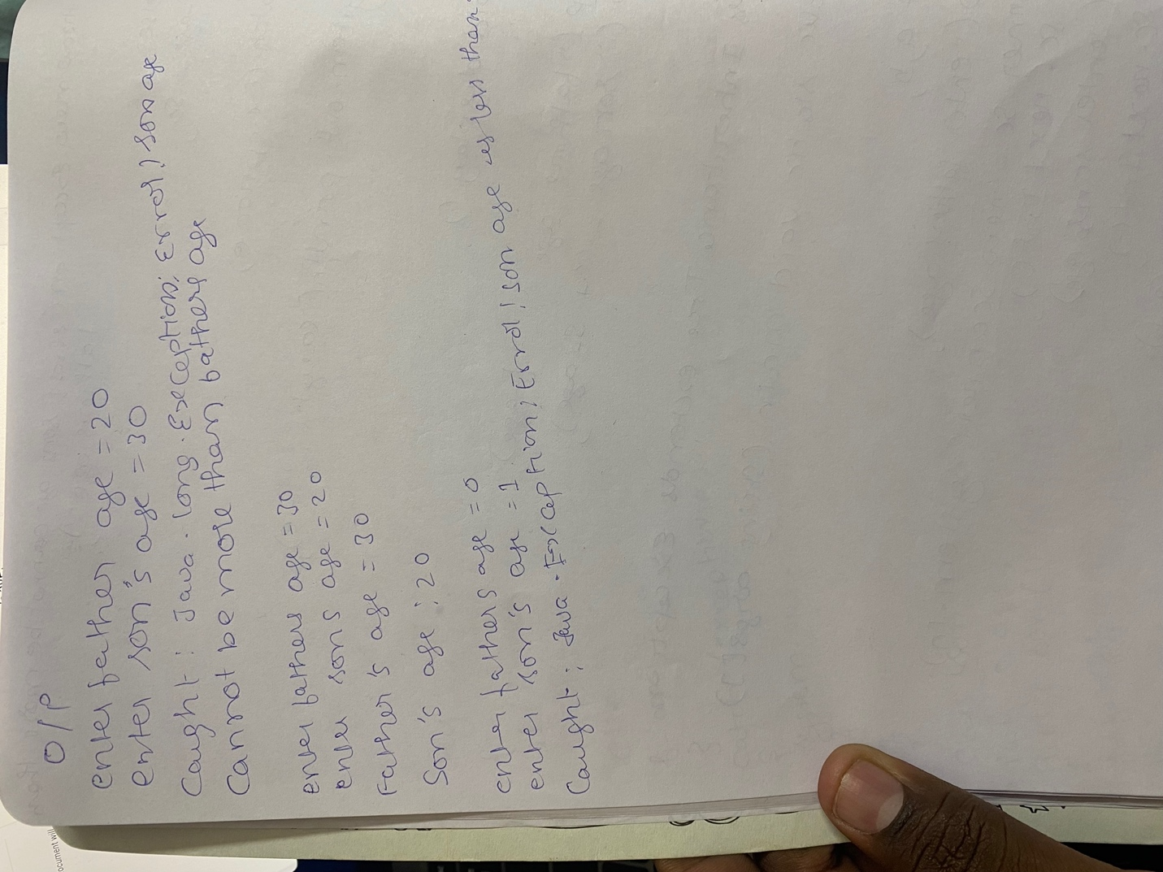

**Output:**

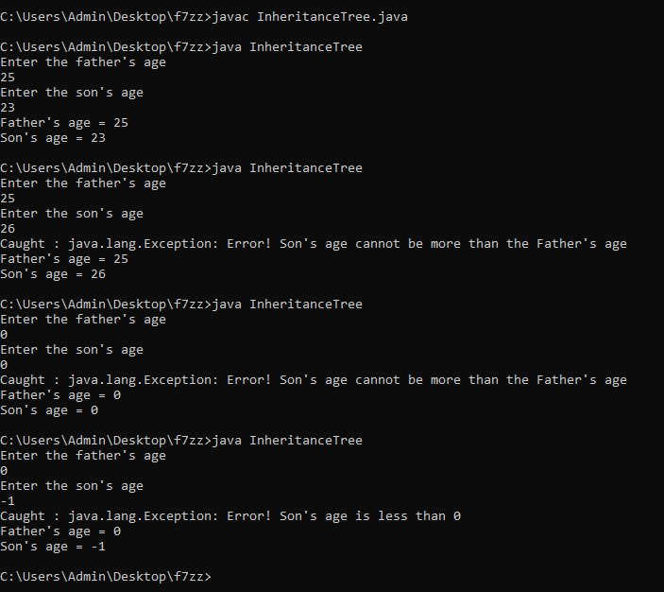

**LAB PROGRAM 8:**

**Q:** Write a program which creates two threads, one thread displaying “BMS College of Engineering” once every ten seconds and another displaying “CSE” once every two seconds.

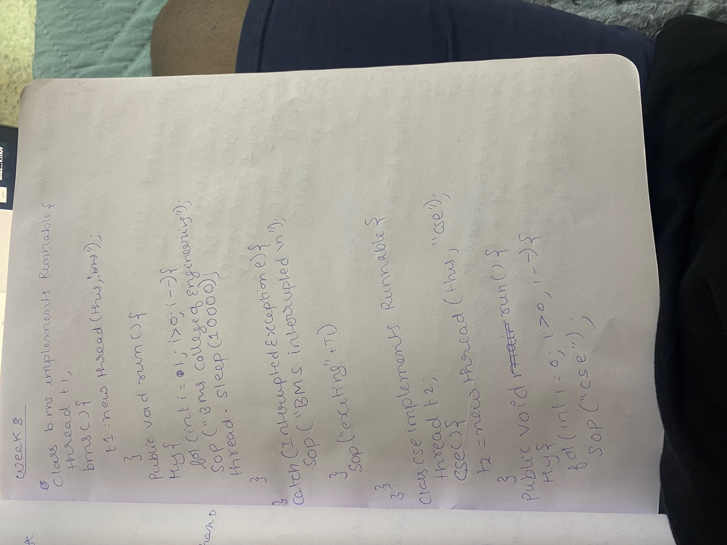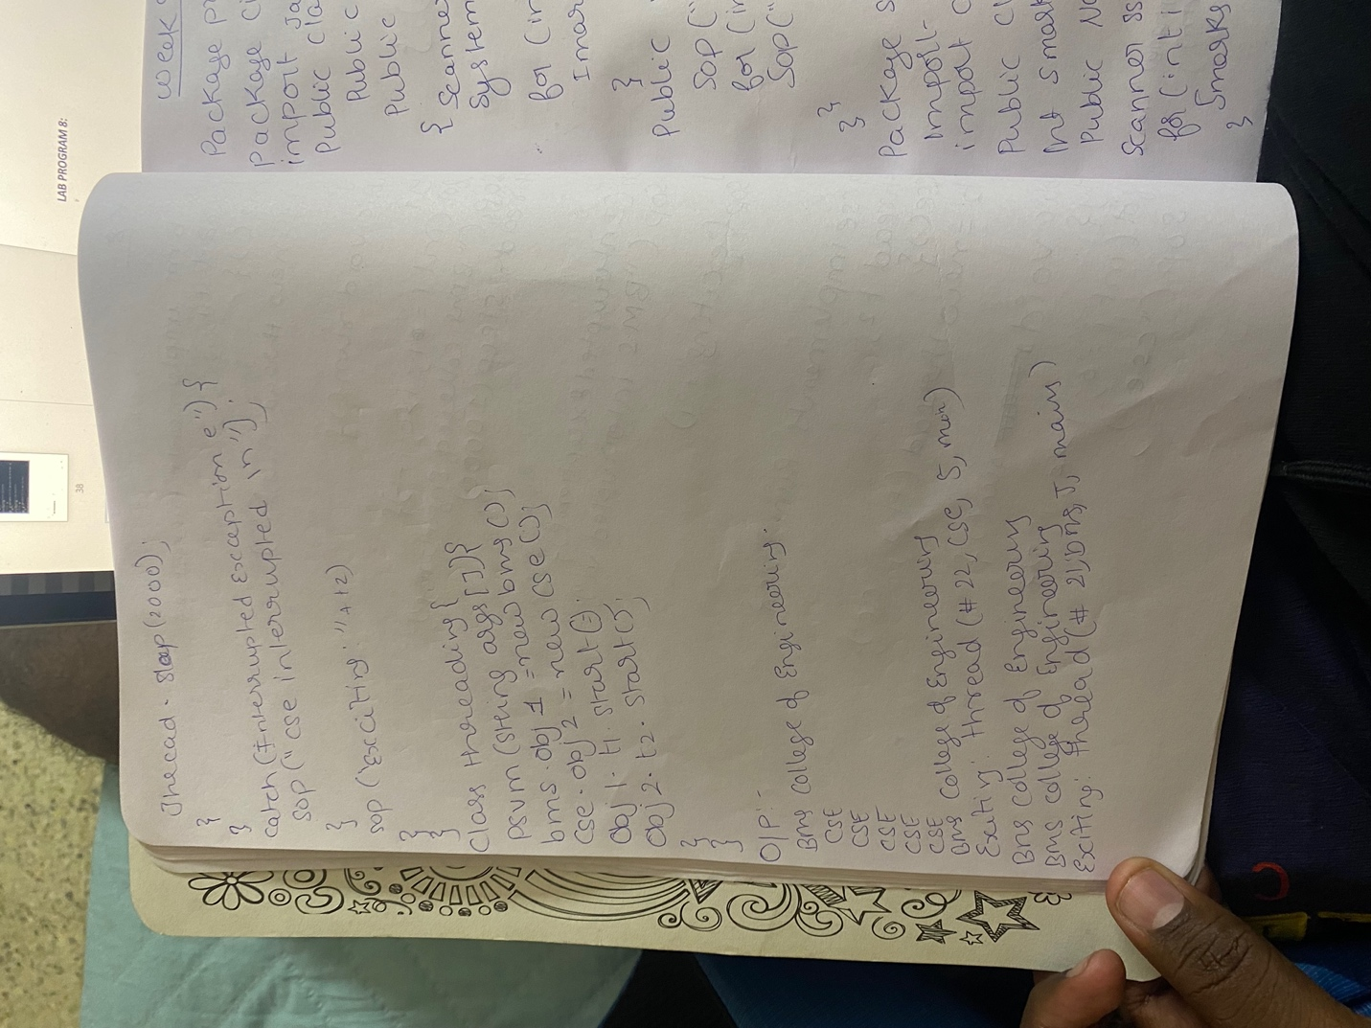

**Output:**

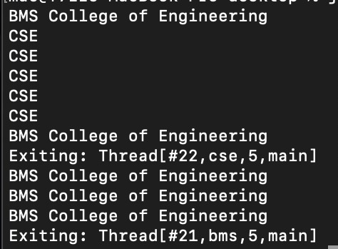

**LAB PROGRAM 9:**

**Q:** Create a package CIE which has two classes- Student and Internals. The class Personal has members like usn, name, sem. The class internals has an array that stores the internal marks scored in five courses of the current semester of the student. Create another package SEE which has the class External which is a derived class of Student. This class has an array that stores the SEE marks scored in five courses of the current semester of the student. Import the two packages in a file that declares the final marks of n students in all five courses.

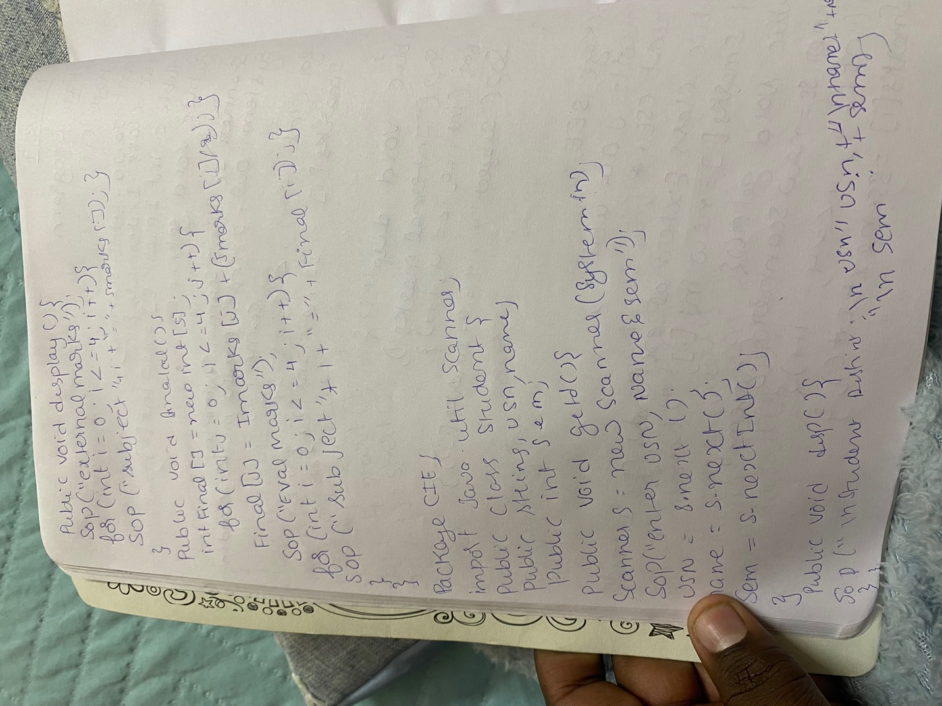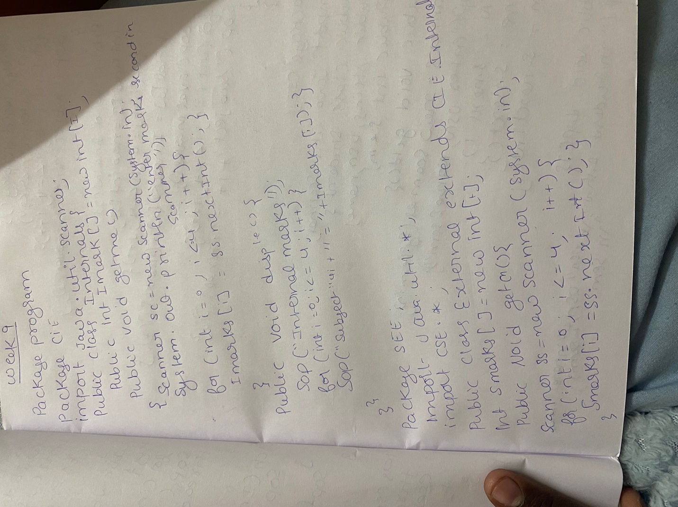

**Output:**

